永磁直流行星齿轮电机（内齿圈材质:金属）
PM DC Planetary Gear Motor (Ring Gear Material: Powder Metal)
28JXF10K/28ZY38
Φ28 行星减速器，允许转矩范围：0.1N.m~1.0N.m
28mm OD Planetary Gearbox,
Permissible Load Range:0.1N.m~1.0N.m
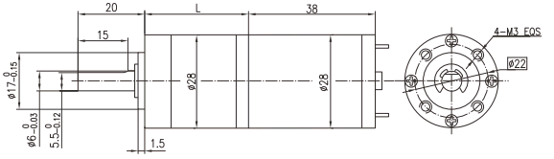
- 外形和安装尺寸Dimensions
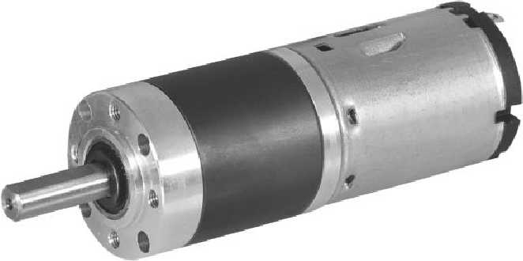
- 电动机主要技术参数Motor Technical Data
电机型号  Type | 额定电压  Rated  voltage  VDC | 空载转速  No-load  Speed  r/min | 空载电流  No-load  Current  mA | 额定转速  Rated  speed  r/min | 额定转矩  Rated  Torque  mN.m | 输出功率  Output  power  W | 额定电流  Rated  Current  mA | 堵转力矩  Stall  Torque  mN.m | 堵转电流  Stall  Current  A
28ZY38-1240 | 12 | 4000 | 80 | 2600 | 7.0 | 1.86 | 350 | 20 | 0.75
28ZY38-1250 | 12 | 5000 | 100 | 3450 | 7.0 | 2.48 | 370 | 21.5 | 0.90
28ZY38-2450 | 24 | 5000 | 60 | 4000 | 6.9 | 2.87 | 200 | 22 | 0.60

- 齿轮减速电机主要技术参数Gear Motor Technical Data
配置28ZY38-1240直流电机(28ZY38-1240 DC Motor)
减速比 Reduction ratio | 3.7 | 5.2 | 14 | 19 | 27 | 51 | 71 | 100 | 139 | 189 | 264 | 369
减速级数 Number of gear trains | 1 | 1 | 2 | 2 | 2 | 3 | 3 | 3 | 3 | 4 | 4 | 4
减速器长度(L) Length(L) mm | 22.6 | 22.6 | 29.2 | 29.2 | 29.2 | 35.6 | 35.6 | 35.6 | 35.6 | 42.0 | 42.0 | 42.0
空载转速 No-load speed r/min | 1078 | 772 | 286 | 211 | 148 | 78 | 56 | 40 | 29 | 21 | 15 | 11
额定转速 Rated speed r/min | 701 | 502 | 186 | 137 | 96 | 51 | 37 | 26 | 19 | 14 | 10 | 7
额定转矩 Rated torque N.m | 0.023 | 0.033 | 0.079 | 0.11 | 0.15 | 0.26 | 0.36 | 0.51 | 0.71 | 0.86 | 1.0 | 1.0
最大瞬间允许负载 N.m  Max. permissible load in a short time | 0.3 | 0.3 | 1.2 | 1.2 | 1.2 | 2.4 | 2.4 | 2.4 | 2.4 | 3.0 | 3.0 | 3.0

配置28ZY38-1250直流电机(28ZY38-1250 DC Motor)
减速比 Reduction ratio | 3.7 | 5.2 | 14 | 19 | 27 | 51 | 71 | 100 | 139 | 189 | 264 | 369
减速级数 Number of gear trains | 1 | 1 | 2 | 2 | 2 | 3 | 3 | 3 | 3 | 4 | 4 | 4
减速器长度(L) Length(L) mm | 22.6 | 22.6 | 29.2 | 29.2 | 29.2 | 35.6 | 35.6 | 35.6 | 35.6 | 42.0 | 42.0 | 42.0
空载转速 No-load speed r/min | 1348 | 965 | 357 | 263 | 185 | 98 | 70 | 50 | 36 | 26 | 19 | 14
额定转速 Rated speed r/min | 930 | 666 | 246 | 182 | 128 | 68 | 49 | 35 | 25 | 18 | 13 | 9.3
额定转矩 Rated torque N.m | 0.023 | 0.033 | 0.079 | 0.11 | 0.15 | 0.26 | 0.36 | 0.51 | 0.71 | 0.86 | 1.0 | 1.0
最大瞬间允许负载 N.m  Max. permissible load in a short time | 0.3 | 0.3 | 1.2 | 1.2 | 1.2 | 2.4 | 2.4 | 2.4 | 2.4 | 3.0 | 3.0 | 3.0

配置28ZY38-2450直流电机(28ZY38-2450 DC Motor)
减速比 Reduction ratio | 3.7 | 5.2 | 14 | 19 | 27 | 51 | 71 | 100 | 139 | 189 | 264 | 369
减速级数 Number of gear trains | 1 | 1 | 2 | 2 | 2 | 3 | 3 | 3 | 3 | 4 | 4 | 4
减速器长度(L) Length(L) mm | 22.6 | 22.6 | 29.2 | 29.2 | 29.2 | 35.6 | 35.6 | 35.6 | 35.6 | 42.0 | 42.0 | 42.0
空载转速 No-load speed r/min | 1348 | 965 | 357 | 263 | 185 | 98 | 70 | 50 | 36 | 26 | 19 | 14
额定转速 Rated speed r/min | 1078 | 772 | 286 | 211 | 148 | 78 | 56 | 40 | 29 | 21 | 15 | 11
额定转矩 Rated torque N.m | 0.023 | 0.032 | 0.078 | 0.11 | 0.15 | 0.26 | 0.36 | 0.50 | 0.70 | 0.85 | 1.0 | 1.0
最大瞬间允许负载 N.m  Max. permissible load in a short time | 0.3 | 0.3 | 1.2 | 1.2 | 1.2 | 2.4 | 2.4 | 2.4 | 2.4 | 3.0 | 3.0 | 3.0
A-7
技术参数如有变动，恕不另行通知

