永磁直流齿轮减速电机 PM DC Spur Gear Motor
允许转矩范围:10N.m
Permissible Load Range: 10N.m
80JB100K/80ZY100

产品特点和用途 Description of The Product
□80mm 的一体式齿轮减速器，允许负载 10.0 N.m。合金结构钢齿轮，全部滚动轴承的配置。
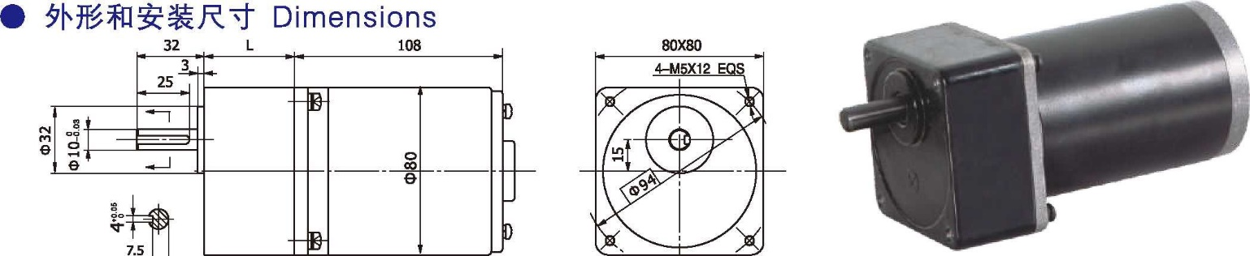
□80mm integrated gearbox, with rated torque up to 10.0 N.m, alloy constructional steel gears, all equipped with ball bearings.
- 电动机特性图 Motor Characteristic Figure
I
- 电动机主要技术参数 Motor Technical Data

电机型号  Type | 额定电压Rated voltage VDC | 空载转速No-load speed r/min | 空载电流No-load current  A | 额定转速Rated speed r/min | 额定转矩Rated Torque mN.m | 输出功率Output power  W | 额定电流Rated current  A | 堵转转矩Stall torque mN.m | 堵转电流Stall Current  A
80ZY100-2420 | 24 | 2000 | 0.4 | 1700 | 0.25 | 45 | 3.0 | 1.5 | 16
80ZY100-2430 | 24 | 3000 | 0.5 | 2600 | 0.30 | 80 | 5.0 | 1.8 | 22

- 齿轮减速电机主要技术参数 Gear Motor Technical Data

配置 80ZY100-2420 直流电机(80ZY100-2420 DC Motor)
减 速 比 | Reduction ratio |  | 3 | 5 | 6 | 7.5 | 9 | 10 | 12.5 | 15 | 18 | 20 | 25 | 30 | 36 | 40 | 50 | 60 | 75
减速级数 | Number of gear trains |  | 2 | 2 | 2 | 2 | 2 | 2 | 2 | 2 | 2 | 3 | 3 | 3 | 3 | 3 | 3 | 4 | 4
减速器长度(L) | Length(L) | mm | 32 | 32 | 32 | 32 | 32 | 32 | 32 | 32 | 32 | 43 | 43 | 43 | 43 | 43 | 43 | 43 | 43
空载转速 | No-load speed | r/min | 667 | 400 | 333 | 267 | 222 | 200 | 160 | 133 | 111 | 100 | 80 | 67 | 56 | 50 | 40 | 33 | 27
额定转速 | Rated speed | r/min | 567 | 340 | 283 | 227 | 189 | 170 | 136 | 113 | 94 | 85 | 68 | 57 | 47 | 43 | 34 | 28 | 23
额定转矩 | Rated torque | N.m | 0.68 | 1.1 | 1.2 | 1.5 | 1.8 | 2.0 | 2.5 | 3.0 | 3.6 | 3.7 | 4.6 | 5.5 | 6.6 | 7.3 | 9.1 | 9.9 | 10
最大瞬间允许负载 N.m  Max. permissible load in a short time |  |  | 5.0 | 5.0 | 5.0 | 5.0 | 5.0 | 5.0 | 5.0 | 5.0 | 5.0 | 15 | 15 | 15 | 15 | 15 | 15 | 20 | 20
转向 | Direction of rotation |  | CW | CW | CW | CW | CW | CW | CW | CW | CW | CCW | CCW | CCW | CCW | CCW | CCW | CW | CW

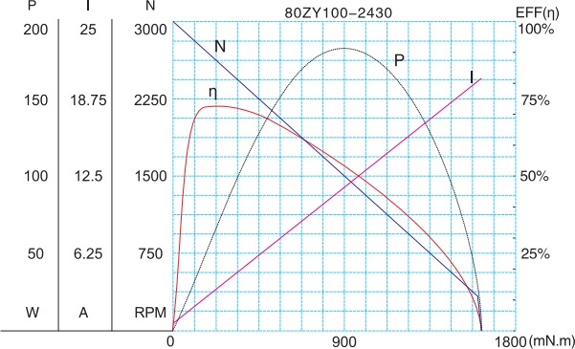
配置 80ZY100-2430 直流电机(80ZY100-2430 DC Motor)
减 速 比 | Reduction ratio |  | 3 | 5 | 6 | 7.5 | 9 | 10 | 12.5 | 15 | 18 | 20 | 25 | 30 | 36 | 40 | 50 | 60 | 75
减速级数 | Number of gear trains |  | 2 | 2 | 2 | 2 | 2 | 2 | 2 | 2 | 2 | 3 | 3 | 3 | 3 | 3 | 3 | 4 | 4
减速器长度(L) | Length(L) | mm | 32 | 32 | 32 | 32 | 32 | 32 | 32 | 32 | 32 | 43 | 43 | 43 | 43 | 43 | 43 | 43 | 43
空载转速 | No-load speed | r/min | 1000 | 600 | 500 | 400 | 333 | 300 | 240 | 200 | 167 | 150 | 120 | 100 | 83 | 75 | 60 | 50 | 40
额定转速 | Rated speed | r/min | 800 | 520 | 433 | 347 | 289 | 260 | 208 | 173 | 144 | 130 | 104 | 87 | 72 | 65 | 52 | 43 | 35
额定转矩 | Rated torque | N.m | 0.81 | 1.2 | 1.5 | 1.8 | 2.2 | 2.4 | 3.0 | 3.6 | 4.4 | 4.4 | 5.5 | 6.6 | 7.9 | 8.8 | 9.9 | 10 | 10
最大瞬间允许负载 N.m  Max. permissible load in a short time |  |  | 5.0 | 5.0 | 5.0 | 5.0 | 5.0 | 5.0 | 5.0 | 5.0 | 5.0 | 15 | 15 | 15 | 15 | 15 | 15 | 20 | 20
转向 | Direction of rotation |  | CW | CW | CW | CW | CW | CW | CW | CW | CW | CCW | CCW | CCW | CCW | CCW | CCW | CW | CW
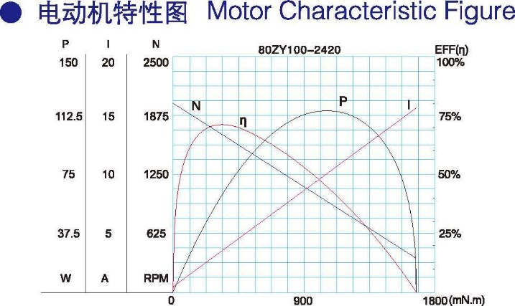
- 电动机特性图 Motor Characteristic Figure
F-12

