永磁直流齿轮减速电机 PM DC Spur Gear Motor
允许转矩范围:5.0N.m
Permissible Load Range:5.0Nm
60JB50K/52ZY125

产品特点和用途 Description of The Product
□60mm 的一体式齿轮减速器，允许负载 5QN.m。合金结构钢齿轮，全部滚动轴承的配置。
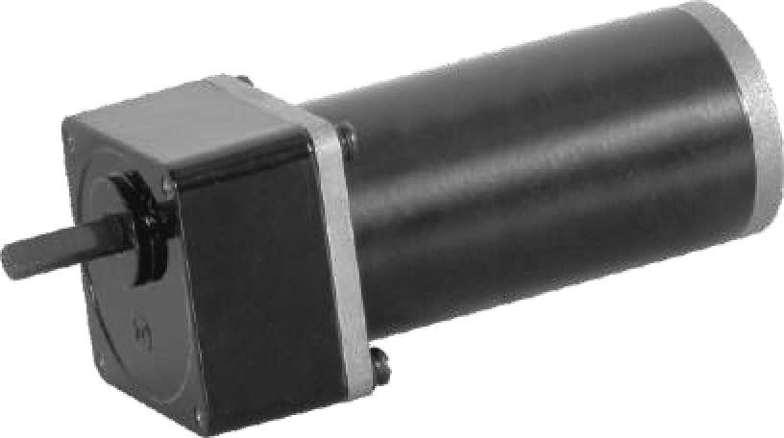
□60mm integrated gearbox, with rated torque up to 5.0 N.m, alloy constructional steel gears, all equipped with ball bearings.

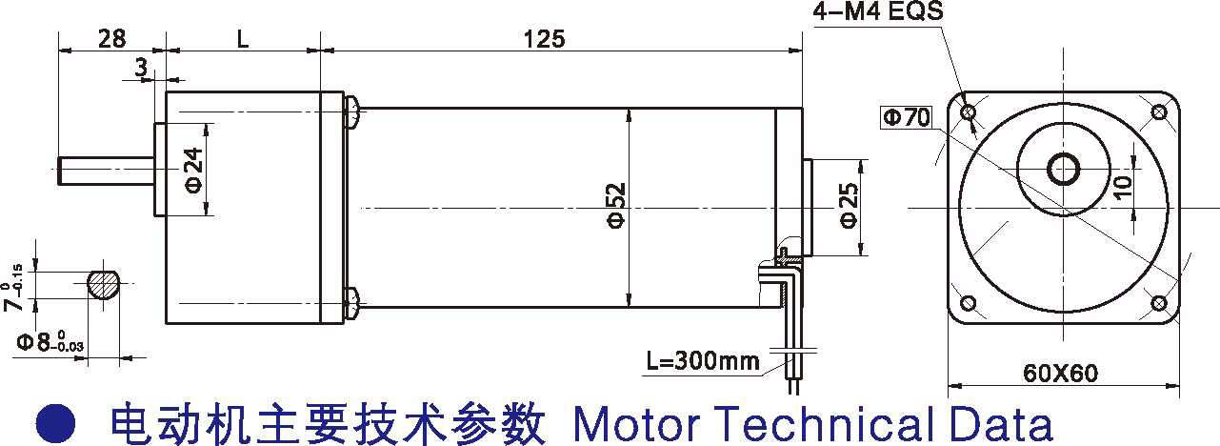外形和安装尺寸 Dimensions

- 电动机主要技术参数 Motor Technical Data
电机型号  TYPE | 额定电压  Rated  voltage VDC | 空载转速No-load Speed  r/min | 空载电流  No-load  current mA | 额定转速Rated Speed  r/min | 额定转矩Rated torque  mN.m | 输出功率Output power  W | 额定电流  Rated  current mA | 堵转力矩Stall Torque m  N.m | 堵转电流  Stall  current A
52ZY125-2420 | 24 | 2000 | 0.40 | 1600 | 160 | 30 | 2.0 | 620 | 6.5
52ZY125-2430 | 24 | 3000 | 0.60 | 2400 | 190 | 50 | 3.5 | 700 | 11.5

- 齿轮减速电机主要技术参数 Gear Motor Technical Data
配置 60ZY75-2420 直流电机(52ZY125-2420 DC Motor)
减 速 比 Reduction ratio
减速级数 Number of gear trains
减速器长度(L) Length(L)
空载转速 No-load speed
额定转速 Rated speed
额定转矩 Rated torque
3
2
32
667
533
0.38
5
2
32
400
320
0.64
7.5
2
32
267
213
0.97
10
2
32
200
160
1.2
12.5
2
32
160
128
1.6
15
2
32
133
106
1.9
最大瞬间允许负载
Max. permissible load in a short time
mm r/min r/min N.m
N.m
25
3
40
80
64
3.2
30
3
40
67
53
3.8
50
3
40
40
32
5.0
5
5
5
5
15
15
15
15
15
转 向 Direction of rotation CW CW CW CW CW CW CCW CCW CCW

配置 52ZY125-2430 直流电机(52ZY125-2430 DC Motor)
减 速 比 Reduction ratio
减速级数 Number of gear trains
减速器长度(L) Length(L)
空载转速 No-load speed
额定转速 Rated speed
额定转矩 Rated torque
3
2
32
1000
800
0.46
5
2
32
600
480
0.76
7.5
2
32
400
320
1.1
10
2
32
300
240
1.5
12.5
2
32
240
192
1.9
15
2
32
200
160
2.3
最大瞬间允许负载
Max. permissible load in a short time
mm r/min r/min N.m
N.m
25
3
40
120
96
3.1
30
3
40
100
80
3.7
50
3
40
60
48
5.0
转 向 Direction of rotation
2.5
CW
2.5
CW
2.5
CW
2.5
CW
2.5
CW
2.5
CW
5.0
CCW
5.0
CCW
5.0
CCW

- 电动机特性图 Motor Characteristic Figure
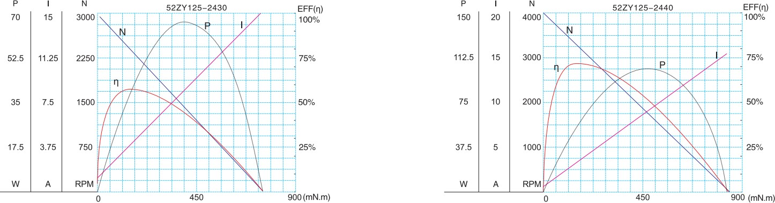

F-7

永磁直流齿轮减速电机 PM DC Spur Gear Motor
N.m
允许转矩范围:5.0N.m
Permissible Load Range:5.0 N.m
60JB50K/60ZY75

产品特点和用途 Description of The Product
□60mm 的一体式齿轮减速器，允许负载 5.0N.m。合金结构钢齿轮，全部滚动轴承的配置。
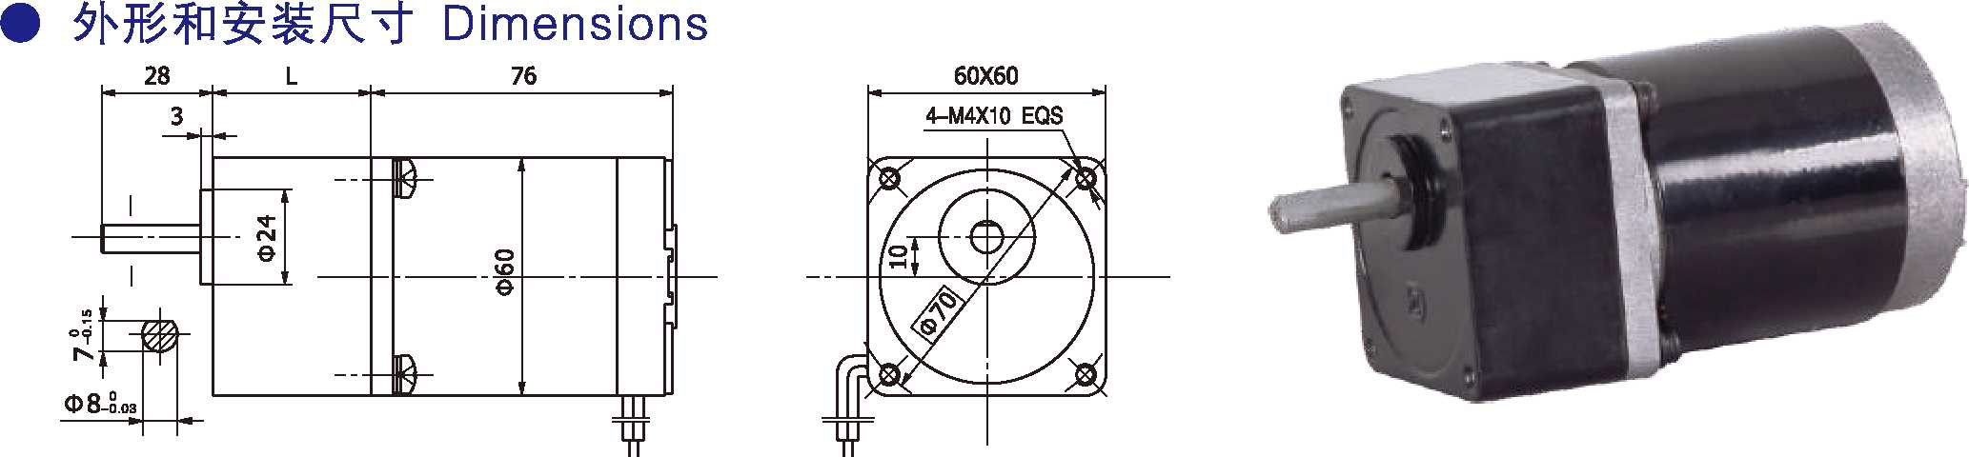□60mm integrated gearbox, with rated torque up to 5.0 N.m, alloy constructional steel gears, all equipped with ball bearings.
- 外形和安装尺寸 Dimensions

电动机主要技术参数 Motor Technical Data
电机型号  TYPE | 额定电压  Rated  voltage VDC | 空载转速  No-load  Sped r/min | 空载电流  No-load  current mA | 额定转速Rated Speed  r/min | 额定转矩Rated torque  mN.m | 输出功率Output power  W | 额定电流  Rated  current mA | 堵转力矩  Stall  Torque m N.m | 堵转电流  Stall  current A
60ZY75-2420 | 24 | 2000 | 0.3 | 1600 | 50 | 8 | 0.8 | 215 | 2.1
60ZY75-2430 | 24 | 3000 | 0.4 | 2400 | 70 | 17 | 1.2 | 296 | 5.0
60ZY75-2440 | 24 | 4000 | 0.5 | 3200 | 90 | 30 | 2.2 | 404 | 8.5

  - 齿轮减速电机主要技术参数 Gear Motor Technical Data
配置 60ZY75-2420 直流电机(60ZY75-2420 DC Motor)
减 速 比 Reduction ratio | 3 | 5 | 7.5 | 10 | 12.5 | 15 | 25 | 30 | 50 | 75 | 90 | 100 | 120 | 150
减速级数 Number of gear trains | 2 | 2 | 2 | 2 | 2 | 2 | 3 | 3 | 3 | 4 | 4 | 4 | 4 | 4
减速器长度(L) Length(L) mm | 32 | 32 | 32 | 32 | 32 | 32 | 40 | 40 | 40 | 40 | 40 | 40 | 40 | 40
空载转速 No-load speed r/min | 667 | 400 | 267 | 200 | 160 | 133 | 80 | 67 | 40 | 27 | 22 | 20 | 17 | 13
额定转速 Rated speed r/min | 533 | 320 | 213 | 160 | 128 | 106 | 64 | 53 | 32 | 21 | 18 | 16 | 13 | 10.5
额定转矩 Rated torque N.m | 0.13 | 0.22 | 0.33 | 0.44 | 0.55 | 0.66 | 1.0 | 1.2 | 2.0 | 2.7 | 3.1 | 3.6 | 4.3 | 5.0
最大瞬间允许负载 N.m Max. permissible load in a short time | 2.5 | 2.5 | 2.5 | 2.5 | 2.5 | 2.5 | 5.0 | 5.0 | 5.0 | 10 | 10 | 10 | 10 | 10
转 向 Direction of rotation | CW | CW | CW | CW | CW | CW | CCW | CCW | CCW | CW | CW | CW | CW | CW
配置 60ZY75-2430 直流电机(60ZY75-2430 DC Motor)
减 速 比 Reduction ratio | 3 | 5 | 7.5 | 10 | 12.5 | 15 | 25 | 30 | 50 | 75 | 90 | 100 | 120 | 150
减速级数 Number of gear trains | 2 | 2 | 2 | 2 | 2 | 2 | 3 | 3 | 3 | 4 | 4 | 4 | 4 | 4
减速器长度(L) Length(L) mm | 32 | 32 | 32 | 32 | 32 | 32 | 40 | 40 | 40 | 40 | 40 | 40 | 40 | 40
空载转速 No-load speed r/min | 1000 | 600 | 400 | 300 | 240 | 200 | 120 | 100 | 60 | 40 | 33 | 30 | 25 | 20
额定转速 Rated speed r/min | 800 | 480 | 320 | 240 | 192 | 160 | 96 | 80 | 48 | 32 | 26 | 24 | 20 | 16
额定转矩 Rated torque N.m | 0.17 | 0.28 | 0.42 | 0.56 | 0.7 | 0.85 | 1.2 | 1.5 | 2.5 | 3.8 | 4.5 | 5.0 | 5.0 | 5.0
最大瞬间允许负载 N.m Max. permissible load in a short time | 2.5 | 2.5 | 2.5 | 2.5 | 2.5 | 2.5 | 5.0 | 5.0 | 5.0 | 10 | 10 | 10 | 10 | 10
转 向 Direction of rotation | CW | CW | CW | CW | CW | CW | CCW | CCW | CCW | CW | CW | CW | CW | CW

- 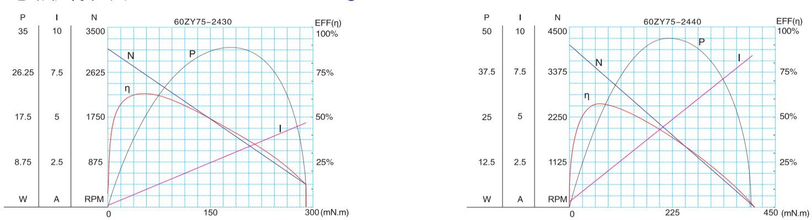电动机特性图 Motor Characteristic Figure
F-8

